Topic: Portfolio Milestone 2 Submission: Engagement Level Diagram

Tripti Vishwakarma
Colorado State University Global
Course Code: CSC 501-2
Bingdong Li
July 29 2024

Creating a Stakeholder Engagement Assessment Matrix and a use case study for each engagement level involves identifying the key stakeholders, their roles, and their level of engagement in the project

Stakeholder Engagement Assessment Matrix

The Stakeholder Engagement Assessment Matrix helps in identifying the current and desired engagement levels of stakeholders. The five engagement levels are:

- Unaware: Stakeholders are not aware of the project and its potential impacts.
- Resistant: Stakeholders are aware of the project but are resistant to change.
- Neutral: Stakeholders are aware of the project but are neither supportive nor resistant.
- Supportive: Stakeholders are aware of the project and support its objectives.
- Leading: Stakeholders are actively engaged in ensuring the project’s success.

C = Current Engagement level
D= Desired Engagement level

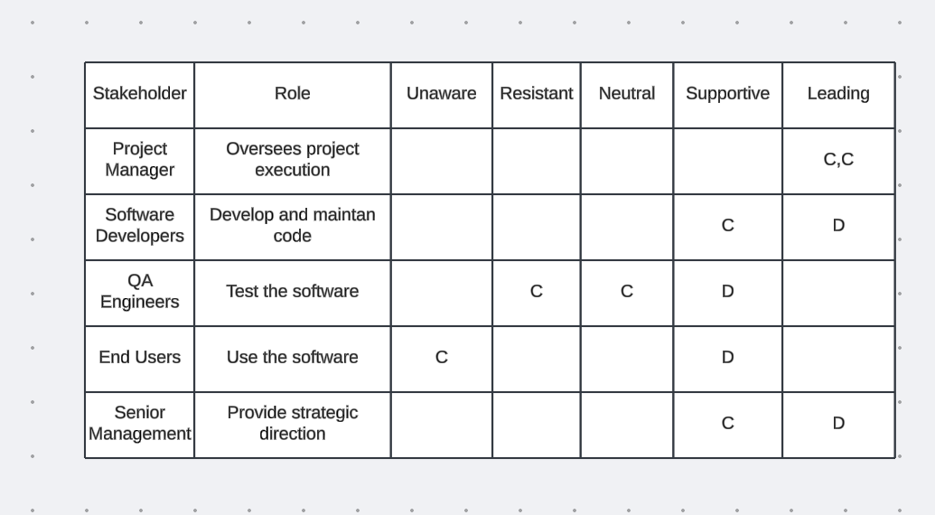

Engagement level diagram.

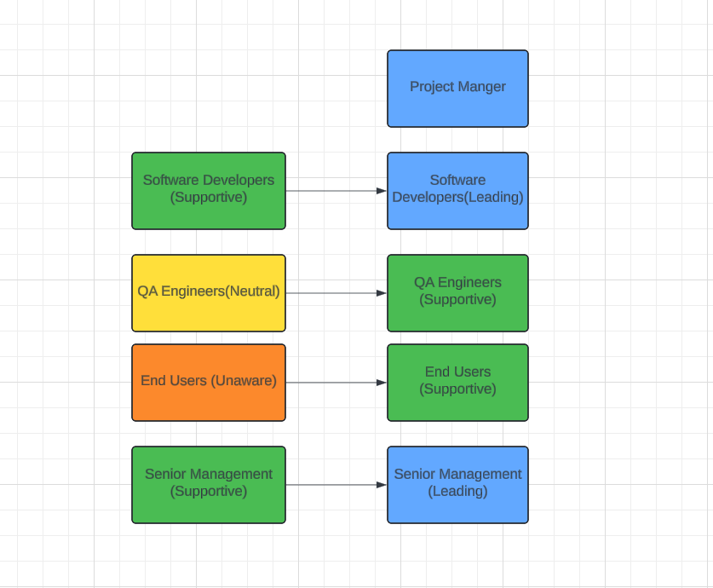

Use Case Study for Each Engagement Level

1. Unaware

Stakeholder: End Users

Current Engagement Level: Unaware

Desired Engagement Level: Supportive

Use Case: End users are currently unaware of the project and its potential benefits. To move them to a supportive level, the project team can conduct awareness campaigns, provide training sessions, and demonstrate how the predictive model can improve their experience with the software.

2. Resistant

Stakeholder: QA Engineers

Current Engagement Level: Resistant

Desired Engagement Level: Supportive

Use Case: QA Engineers might be resistant to the new model due to concerns about additional workload or changes in their testing processes. To address this, the project team can involve QA Engineers early in the development process, seek their input, and show how the model can help in identifying potential issues earlier, thus improving the overall quality of the software.

3. Neutral

Stakeholder: QA Engineers

Current Engagement Level: Neutral

Desired Engagement Level: Supportive

Use Case: QA Engineers are aware of the project but are neither supportive nor resistant. To engage them, the project team can provide detailed information about the model, its benefits, and how it integrates with their current workflow. Regular updates and feedback sessions can also help in gaining their support.

4. Supportive

Stakeholder: Software Developers

Current Engagement Level: Supportive

Desired Engagement Level: Leading

Use Case: Software Developers are supportive of the project and understand its benefits. To move them to a leading role, the project team can involve them in decision-making processes, encourage them to take ownership of certain aspects of the model, and provide opportunities for them to lead sub-teams or specific tasks.

5. Leading

Stakeholder: Project Manager

Current Engagement Level: Leading

Desired Engagement Level: Leading

Use Case: The Project Manager is actively engaged in ensuring the project’s success. To maintain this level of engagement, the project team should ensure that the Project Manager has all the necessary resources, support, and information. Regular progress meetings, transparent communication, and recognition of their efforts can help in sustaining their leadership role.

References-

- 24FA-CSC501-2[Based on Project Management Professional (PMP) Based on PMBOK7] https://seu-csuglobal.ucertify.com/app/?func=load_course&course=PMI-PMP.AB1&class_code=08wcC

- Title: Project Management: Practices, Challenges and Developments Author: Hoffmann, Elizabeth C.https://eds-p-ebscohost-com.csuglobal.idm.oclc.org/eds/ebookviewer/ebook/bmxlYmtfXzY2NDA4M19fQU41?sid=f068df41-1853-4639-84fe-85adc17cf124@redis&vid=1&format=EB&lpid=lp_iii&rid=0

- Project Management: Guideline for the Management of Projects, Project Portfolios, Programs and Project-oriented Companies. Author: Gerold Patzak, Günter Rattay https://eds-p-ebscohost-com.csuglobal.idm.oclc.org/eds/ebookviewer/ebook/bmxlYmtfXzE4MzQ1MDhfX0FO0?sid=e9e9415c-b079-4907-93f5-6276acd7a23e@redis&vid=1&format=EB&lpid=lp_387&rid=0

- Software Maintenance: Concepts and Practice" by Penny Grubb and Armstrong A. Takang https://books.google.com/books?id=ge8o_VkAsiYC&printsec=frontcover&source=gbs_ge_summary_r&cad=0#v=onepage&q&f=false

- Becoming a PMP® Certified Professional: A Study Guide to Mastering Project Management for the PMP® Exam, Author: J. Ashley Hunt

https://eds-p-ebscohost-com.csuglobal.idm.oclc.org/eds/ebookviewer/ebook/bmxlYmtfXzI3NjIxMTRfX0FO0?sid=ca959cc0-83bb-4fb9-b146-56d8ab0b3764@redis&vid=1&format=EB&lpid=lp_3&rid=0

